Practical-02

Q1. Write a shell script to scan your name and display it like My college Name is :UVPCE

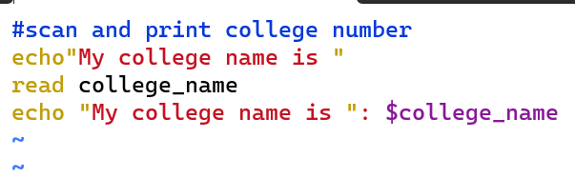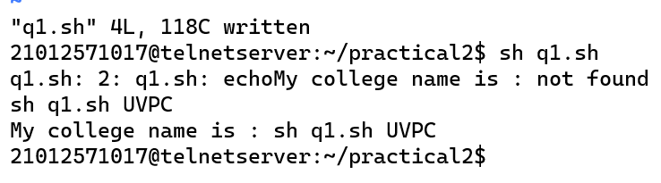

Q2. Write a shell script to scan two variables and to display their sum, mul, div, sub and modulo division.

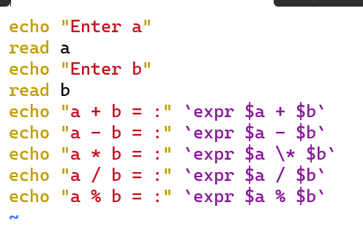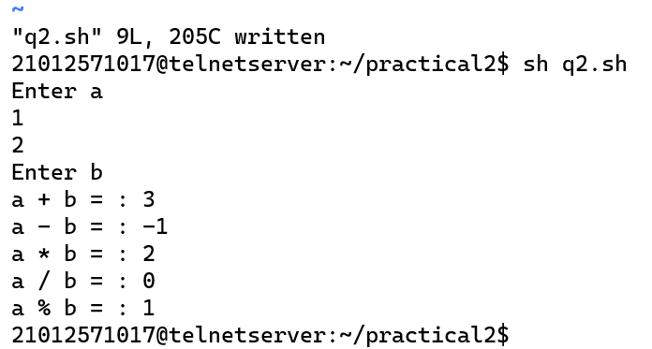

Q3. Write a shell script to scan two variables and to display their sum, mul, div, sub and modulo division as per the user choice. (no need to continue, only once is OK).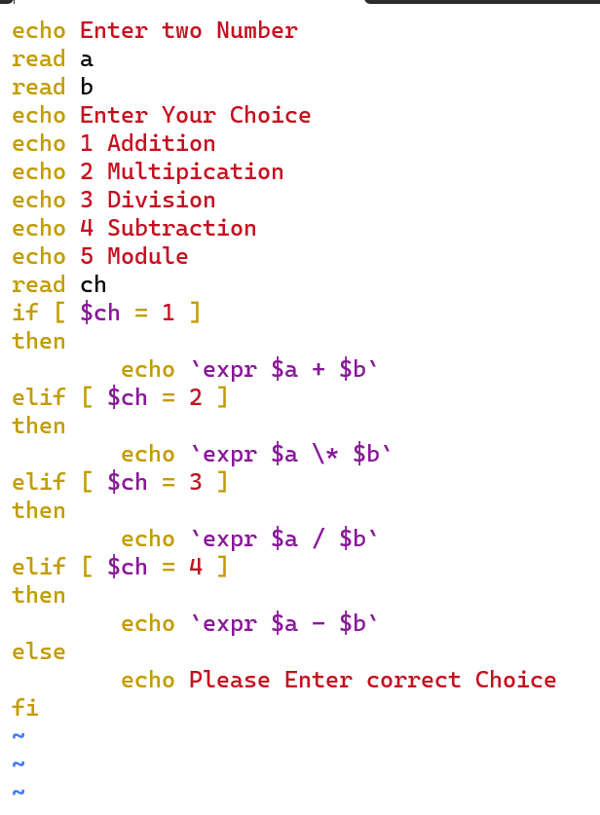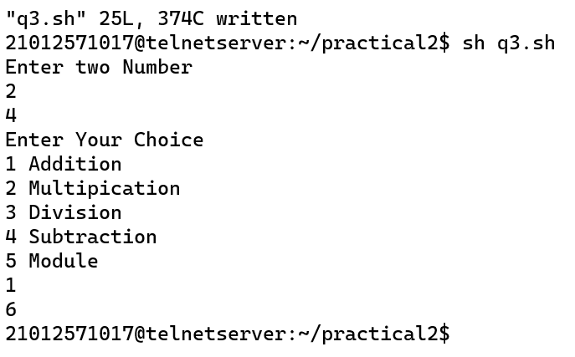

Q4. Write a shell script to find greatest of two. Script must consider the case where two numbers are equal.

